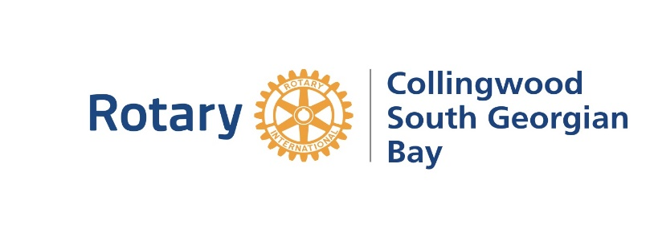
Funding Request

Category A) (0-$1000)
- Join us for coffee and a photo opportunity at one of our Thursday meetings or we can participate in one of your community events
- Provide a 5-10 minute presentation to explain where the money will be going and what it will be used for
- Social Media Recognition on FB/twitter/Instagram announcing our community partnership
- Please provide a photograph, logo and description of how this partnership will/has made a difference

Category B) ($1000-$2500)
- Media release and cheque presentation photograph issued to local media partners, arranged by receiving organization
- 30 minute presentation to our club on project being funded, NGO and other important details and share your upcoming activities or events that our Rotarians can participate in
- Social Media Recognition on FB/twitter/Instagram
- 1 Blog post online on Social Media regarding the project and Rotary’s contribution
- 5-10 minute presentation at the end of the year to provide an update on the project
- Recognition on NGO/Donor Website announcing our community partnership
- Please provide a photograph, logo and description of how this partnership will/has made a difference

Category C) ($2500+)
- Media release and cheque presentation photograph issued to local media partners, arranged by receiving organization
- 30 minute presentation to our club on project being funded, NGO and other important details and share your upcoming activities or events that our Rotarians can participate in
- Social Media Recognition on FB/twitter/Instagram
- 1 Blog/post online on Social Media regarding the project and Rotary’s contribution
- 5-10 minute meeting at the end of the year to provide a status update on project progress
- Recognition on NGO/Donor Website announcing our community and share your upcoming activities or events that our Rotarians can participate in partnership
- Please provide a photograph, logo and description of how this partnership will/has made a difference

